Physical Inventory - Workflow Functional Document

Application: | NGERP-CENTRA
WorkFlow: | Store to Shelf
WorkFlow Item Name: | Physical Inventory

Description
This workflow used to create the Physical inventory and Physical inventory Gift in to the ROW. Which may help to move to stock from one region to others.

Work Flow Process:

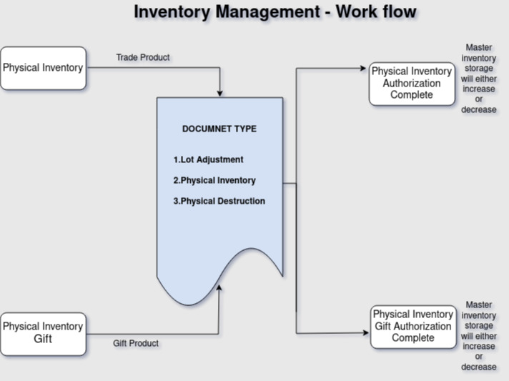

Business Rules:

- In our Inventory Management system, we categorize products into Trade and Non-Trade. Trade products represent the Physical Inventory, while Non-Trade products are considered as Physical Inventory gifts.

Physical Inventory:
- Physical inventory is used to mater inventory storage will increase or decrease for that we are using three document types in physical inventory.
- Document type : Lot Adjustment , Physical inventory and Physical destruction
- Lot Adjustment : When selecting the Lot Adjustment Document type, we adjust the product quantity within the same warehouse and for the same product, but at different locators.
- Physical inventory : When selecting the physical inventory Document type, The product was count was decrease the suspense warehouse.
- Physical destruction : When selecting the Physical destruction Document type, The damage Product count was decrease in damage warehouses.
Physical Inventory Authorization:
- After create Physical Inventory move the physical inventory Authorization screen. Based on Physical Inventory Screen document type the product storage will either increase or decrease.

Physical Inventory Gift:
- Physical inventory gift is used to mater inventory storage will increase or decrease for that we are using three document types in physical inventory.
- Document type : Lot Adjustment , Physical inventory and Physical destruction
- Lot Adjustment : When selecting the Lot Adjustment Document type, we adjust the product quantity within the same warehouse and for the same product, but at different locators.
- Physical inventory : When selecting the physical inventory Document type, The product was count was decrease the suspense warehouse.
- Physical destruction : When selecting the Physical destruction Document type, The damage Product count was decrease in damage warehouses.
Physical Inventory Authorization Gift:
- After create Physical Inventory Gift move the physical inventory Authorization gift screen. Based on Physical Inventory gift Screen document type the product storage will either increase or decrease.

